Red Brick Building Centre Ltd, Morland Enterprise Park, Morland Road, Glastonbury Somerset BA6 9FT

INVITATION TO INVEST IN A LOCAL COMMUNITY PROJECT – BE PART OF THE FUTURE
About the Red Brick Building
The Red Brick Building Ltd (RBB) is an innovative community-owned social enterprise based in the former Morlands Factory situated between Glastonbury and Street in Somerset.
In the last six years two of the three derelict buildings have been transformed into a vibrant community space for all ages. This includes affordable hot desking space; workspaces for social enterprises and small businesses; an award-winning restaurant; a local FM radio station; artisan workshops; a holistic health practice; a youth club and a space hosting a variety of events for the local community including regular gigs, the Glastonbury Film Challenge and more. All of this has been achieved with a voluntary Board of Directors, a very small staff team and limited funds.
The RBB is a Community Benefit Society (CBS) owned by its 300 community shareholders who have invested £122,000 in the organisation. Additional significant investment of £460,000 has come from members of the RBB Investors Club and this has played a vital role in providing the additional investment required to bring the project to where it is today. Grants of over £310,000 have also been awarded. In all £892,000 has been raised so far.
In recent months the project has received a grant from Power to Change of £248,000 to invest in infrastructure and staffing. This grant requires match funding to make Building C, the next phase of the restoration, watertight. This urgent work will put a roof on the building and undertake some necessary demolition.
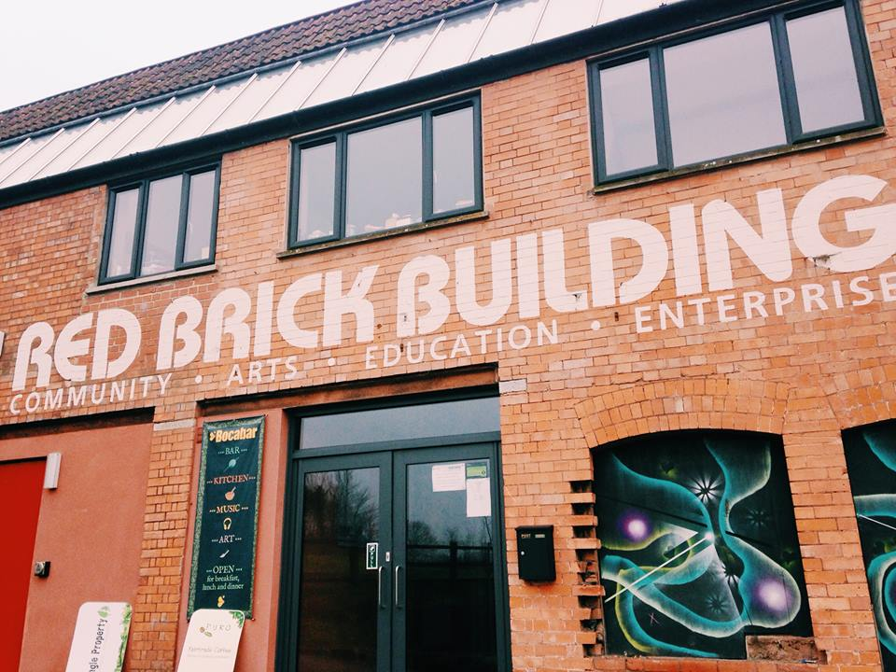
Buildings A and B
What happens next?
We want the RBB to become a pioneering centre for arts, design, manufacture and culture here in Somerset, providing rewarding, productive and skilled work for generations to come, thus reversing the process of ‘rural exodus’ which has seen our young people leave the area in search of employment.
Following community consultation, the project is now focussing on developing community arts and education integrated with community heritage manufacturing. The aim is to create an Enterprise and Apprenticeship Hub, particularly for young people, whom we hope will be able to design and produce goods, providing much needed opportunities for employment within the community. We envisage this being around shoes, wool and willow to reflect the heritage of the local area.
We have also been talking to the Alfred Gillett Trust about opportunities around getting an anchor tenant for Building C. The Trust says it is grateful to the RBB for the opportunity to investigate a partnership project which would restore Building C and return it to public use. The Trust has commissioned an options appraisal of the scheme which would deliver a variety of community assets including work-based learning opportunities and access to the internationally important collections in the Trust’s care. Each option will prioritise community needs and promote multi-disciplinary learning whilst preserving this important feature of Somerset’s industrial heritage. The Alfred Gillett Trustees will consider the Red Brick proposal as part of a wider discussion about the Trust’s capital development programme.
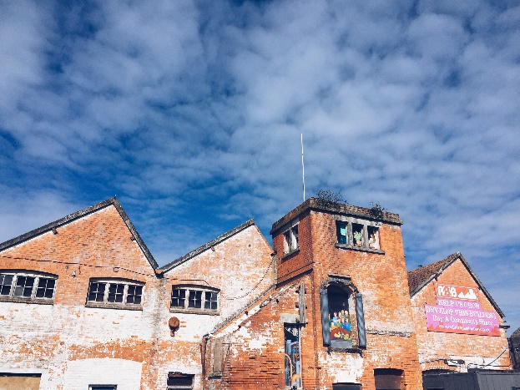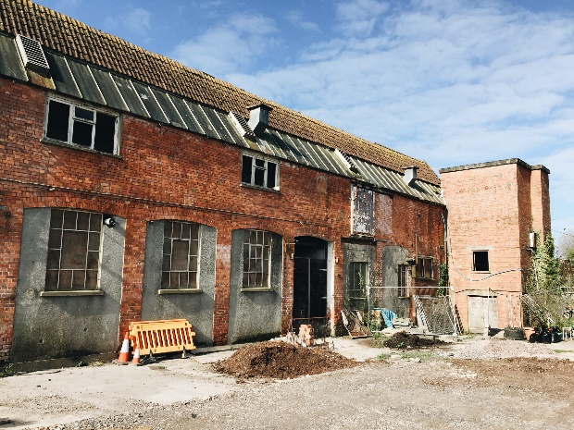
Building C
Why is the Red Brick Building seeking investment?
All of the funds raised through our initial investments have been utilised to produce the incredible resource that is the Red Brick Building. We now want to build on that to provide even more exciting opportunities and space for the local community. We need new investors to help us. We need to secure the funds to enable the project to move towards the next phases, the first being securing Building C to ensure it doesn’t deteriorate further.
Initially we need £256,581 to put a new roof on the building and for some necessary demolition works.
Our fundraising will continue over the next few years, in stages, to carry out further works to the building, securing the shell, fitting it out with services (electricity, water and more), fitting it out for tenants and making the adaptations to buildings A and B to connect them to C. The costs for this will be £1,975,595 including contingencies.
Any amount received over and above Phase 1 target costs will be put towards further phases of the development.
We will need to obtain as much local support through individual investors and local Charitable Trusts as we can for phases I and 2. We will then to go to national charities and individual investors, who are significantly more likely to help us if they can see that local people are also helping us.
How can you become a part of it?
We welcome more investment through our open community share offer. To become a shareholder requires a minimum of 100 shares and each share costs £1. Each shareholding member has one vote, regardless of the size of their shareholding. The maximum permissible shareholding is £100,000.
A share application form can be downloaded from our website www.redbrickglastonbury.co.uk/shareholder for completion and return to us at the Red Brick Building.
We want to make shares accessible to everyone. £100 is the minimum shareholding, and £100,000 is the maximum shareholding to become a member. Each member has one vote regardless of the number of shares they own. But you can pay for your 100 shares over a year in 4 instalments of £25. Or you can buy a half share with a friend or relative, and share your vote.
Benefits of investing and social return
By investing in the development of the Red Brick Building, you will be supporting something with clear community benefit. The key benefits are:
- Contributing to a long term community asset serving the people of Glastonbury, Street and surrounding villages
- The provision of accessible and affordable working spaces for artists, small businesses and social enterprises, thus supporting sustainable economic activity in the area.
- The provision of space for a wide variety of community services, including training, education, arts and entertainment
- Making a significant contribution to the wellbeing and vitality of the local economy
Nature of the investment and the legal information
The shares which Red Brick Building Centre Ltd is issuing are withdrawable shares. That means that they can only be sold back to the Society, not sold to others. They do not change in value while they remain invested. If withdrawn, their value will be at (or possibly below) their face value. The terms for withdrawal are set out in the Society's Rules.
This should be regarded as a long term investment. Red Brick Building Centre Ltd anticipates that it will not be able to allow for withdrawals in the first three years following investment. This investment should be considered as an opportunity to contribute financially to the community with the expectation of a social dividend rather than a financial one. Over the longer term, RBBC Ltd will aim to allocate part of its accumulated reserves to a fund which will allow for occasional withdrawal. Failing this, it will undertake an open share issue where funds from incoming members can replace a limited number of withdrawals.
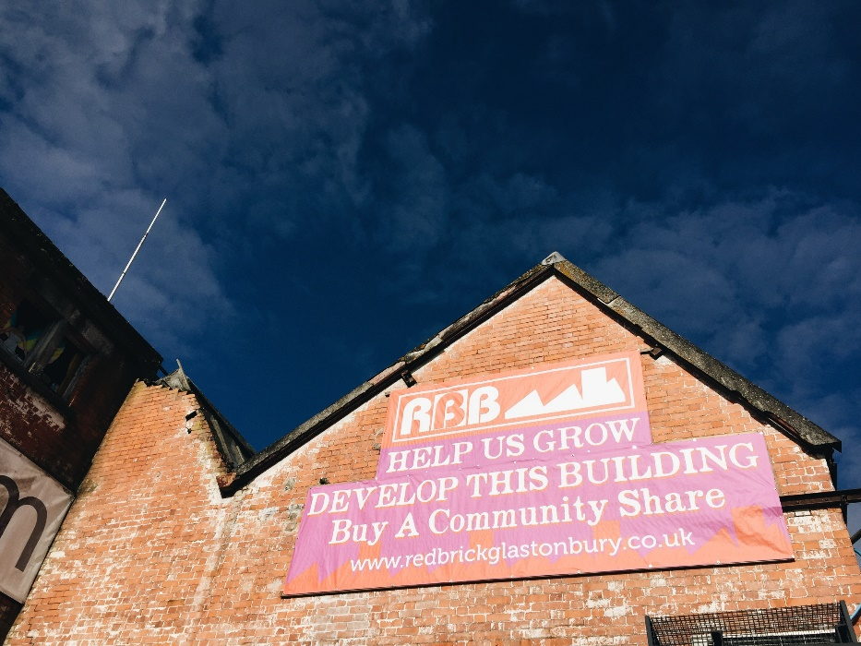
Asset Lock
The rules of the Society contain a statutory asset lock which cannot be removed by members' resolution and which restricts the ability of the Society to use or deal with its assets other than for the benefit of the community. The only payments which can be made to members are the value of withdrawable share capital or interest on that withdrawable share capital. This means that the value of the Society's assets, including ownership of the Red Brick Building, is secured for community benefit. The assets of the Society can never be used for individual gain.
Risks
Specific risks associated with this investment are: The costs of the works detailed may overrun the budget. This risk has been mitigated by seeking detailed quotes, and all building work will be tightly managed. Detailed work specifications have been developed by our architect and his team. General risks associated with this investment are: Withdrawable shares carry risks. We do not want people to invest money they cannot afford to lose. Our governing document, the Rules, is available online and explain member/ shareholders rights.
Regulation
Our share offer is exempt from the Financial Services and Markets Act 2000 or subsidiary regulations; this means that you have no right of complaint to an ombudsman. A Community Benefit Society is registered with but not authorised by the Financial Conduct Authority and therefore the money you invest is not safeguarded by a depositor protection scheme or dispute resolution scheme. The whole of your investment will be at risk (although you can’t lose more than you invest). Please consider carefully in the context of the information provided and, if needed, seek independent advice.
Details of the following can be found on www.redbrickglastonbury.co.uk
- Rules of the society
- Board of Directors
- Details of our tenants and events at the building
For further information, please email enterprise@redbrickglastonbury.co.uk

